VLSI HW1

106061151 電機大三 劉安得

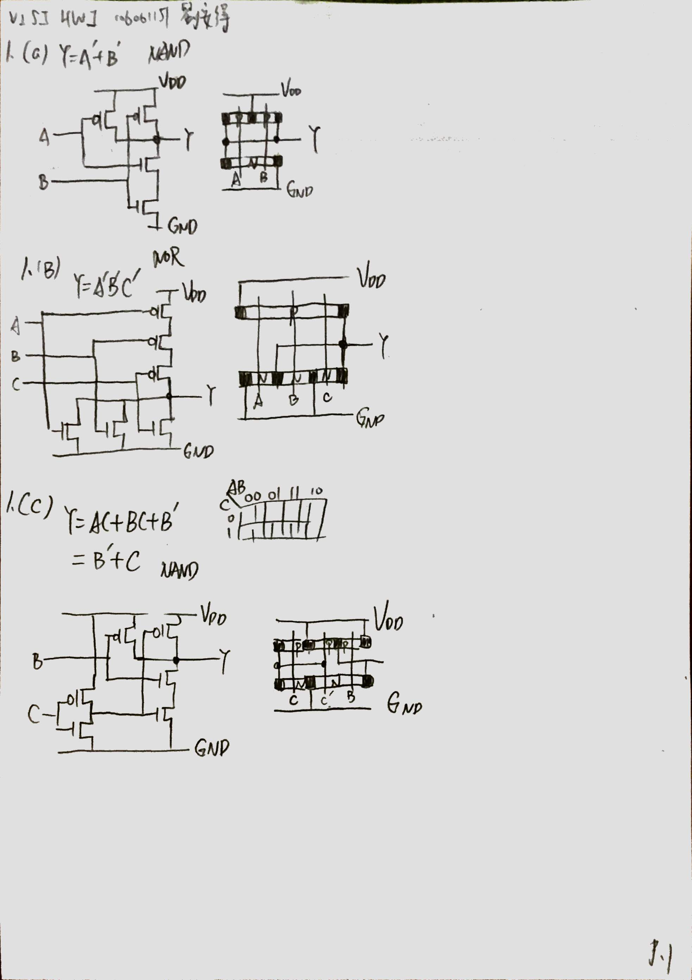

3. (a)

|  |  |
| --- | --- |
| PMOS width | Vout |
| 0.25 um | 66.9 mV |
| 0.5 um | 163.6 mV |
| 1 um | 658 mV |
| 1.1 um | 854 mV |
| 1.12 um | 893 mV |
| 1.13 um | 912 mV |
| 1.15 um | 950 mV |
| 1.2 um | 1.04 V |
| 1.25 um | 1.124 V |

1.12 um is the optimal width for PMOS

3 (b) (c)

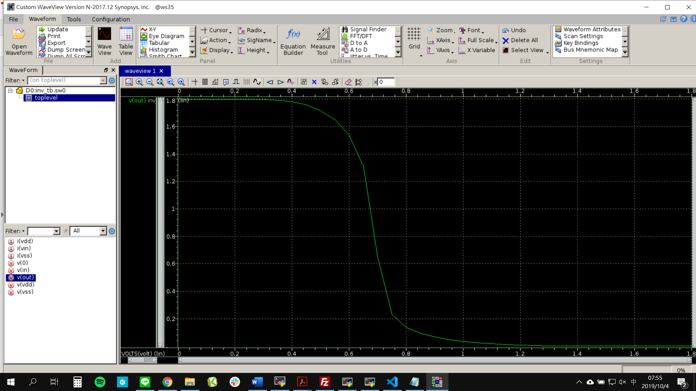

TT width 1x

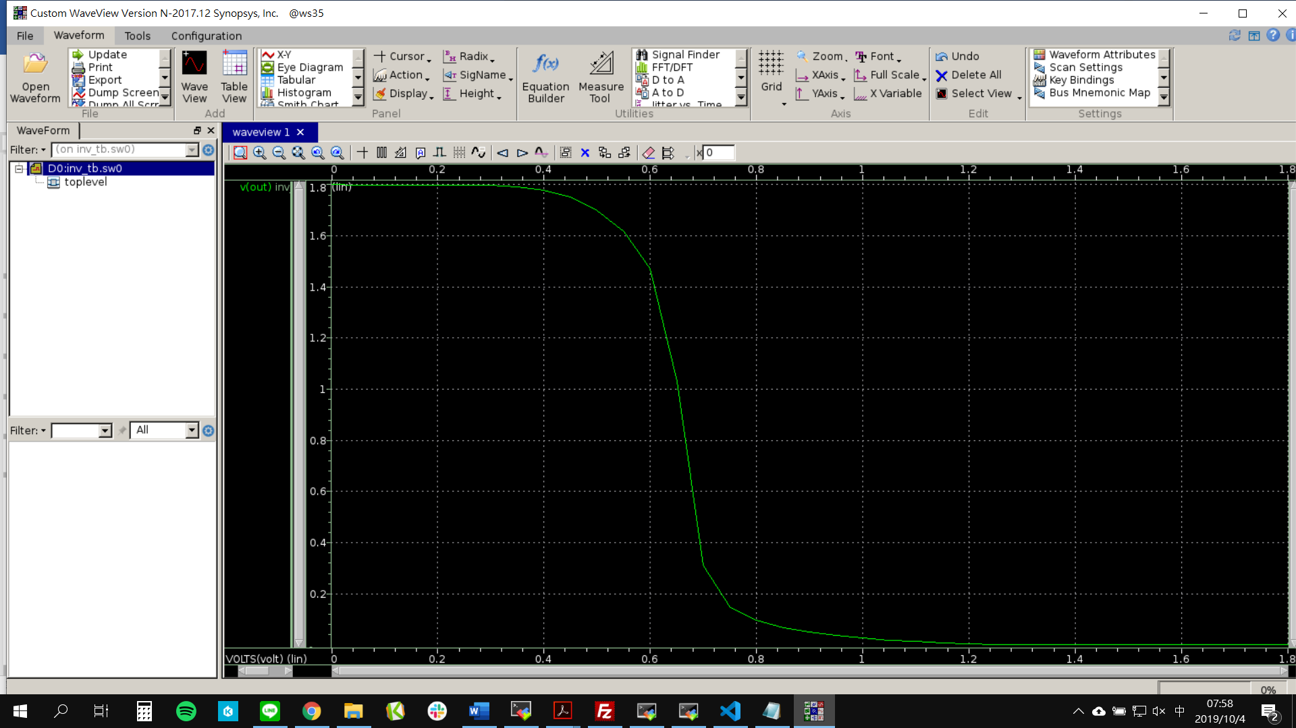

FF width 1x

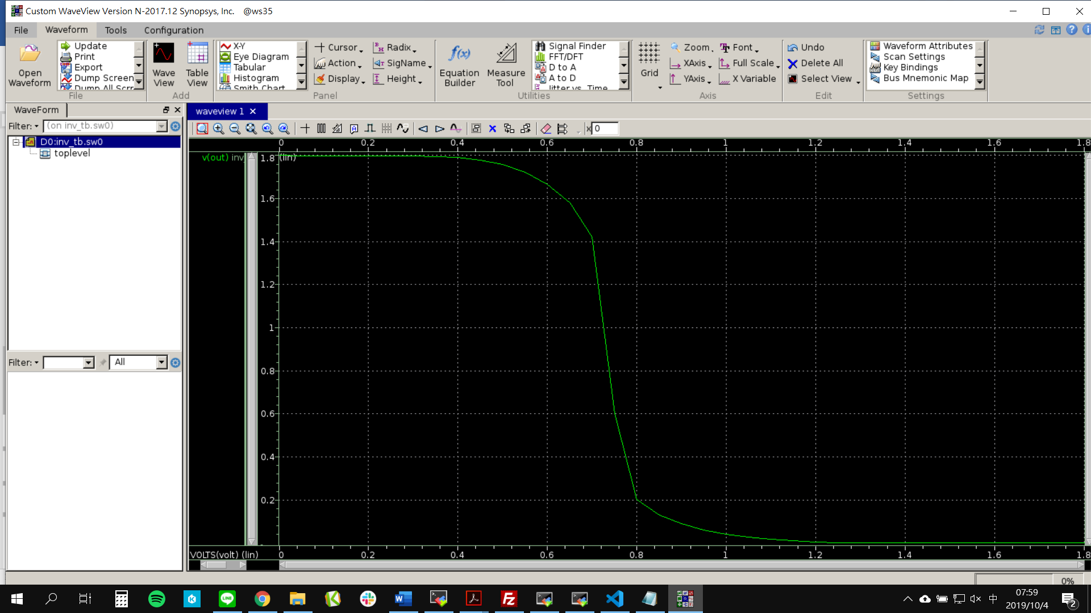

SS width 1x

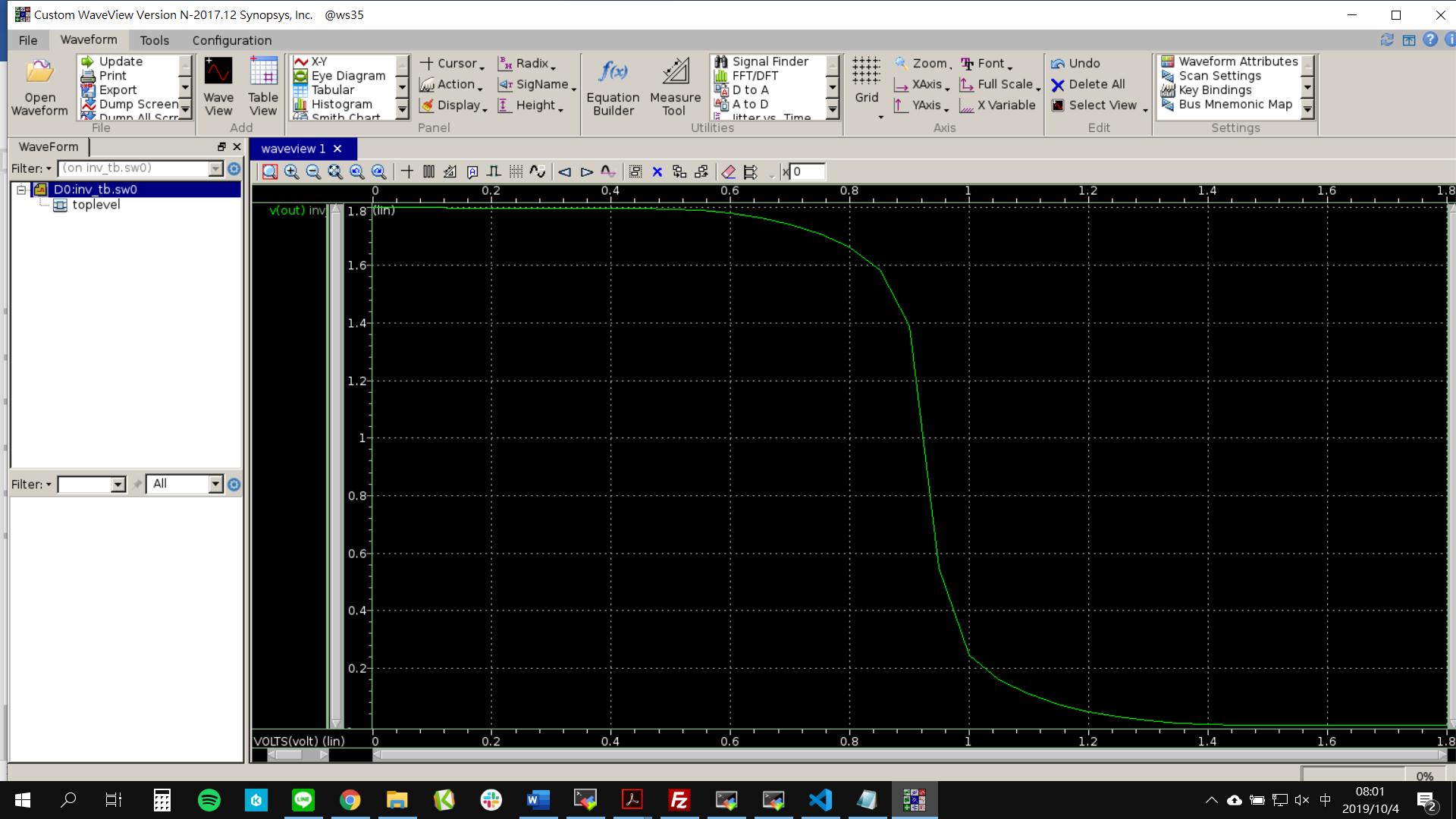

SF width 1x

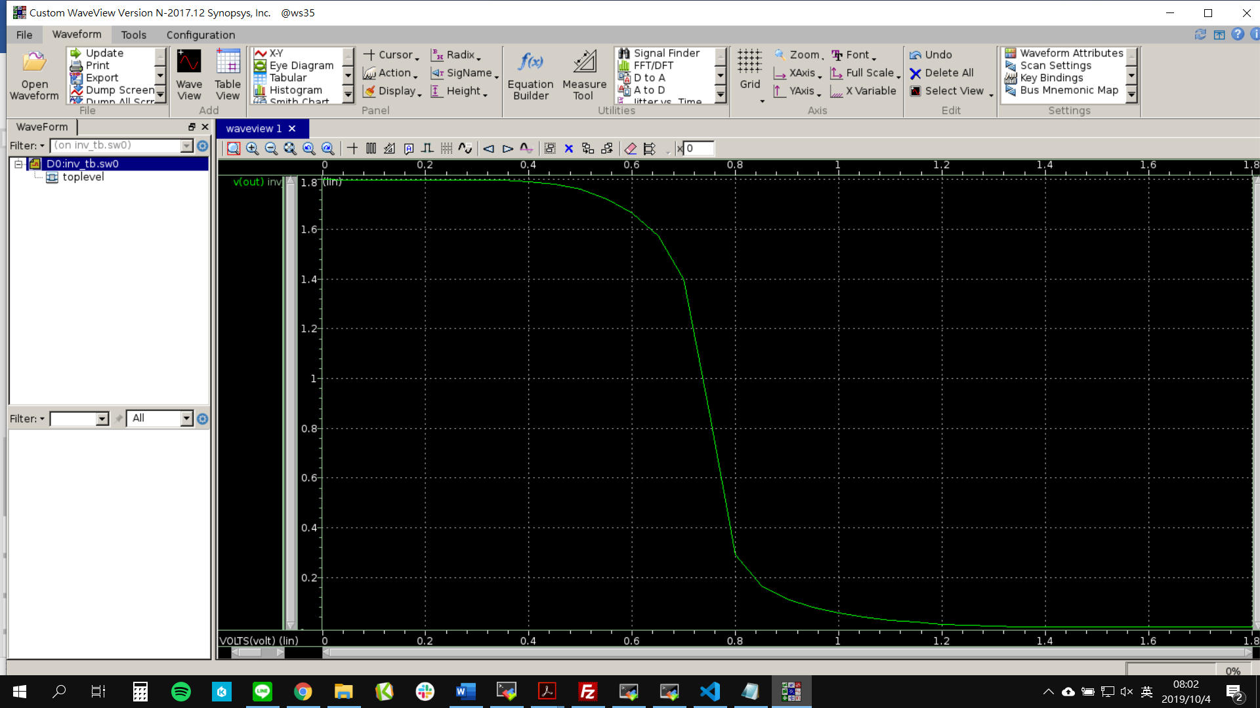

FS width 1x

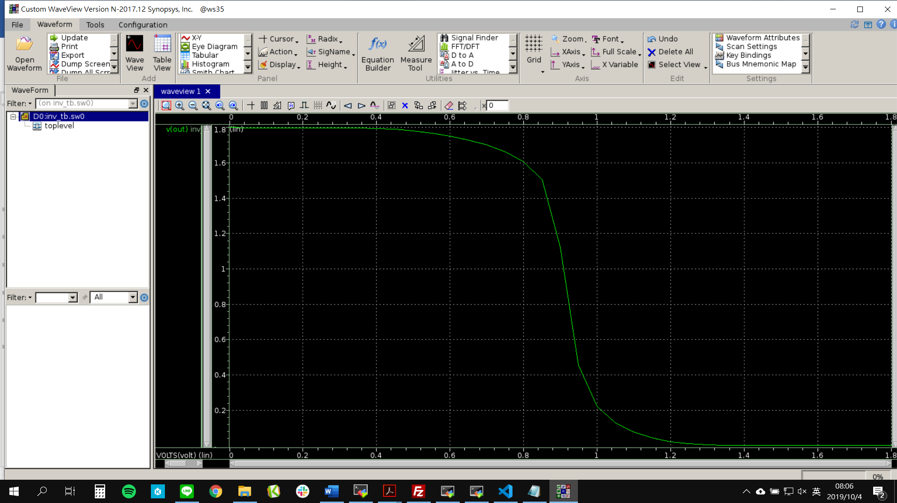

TT width 5x

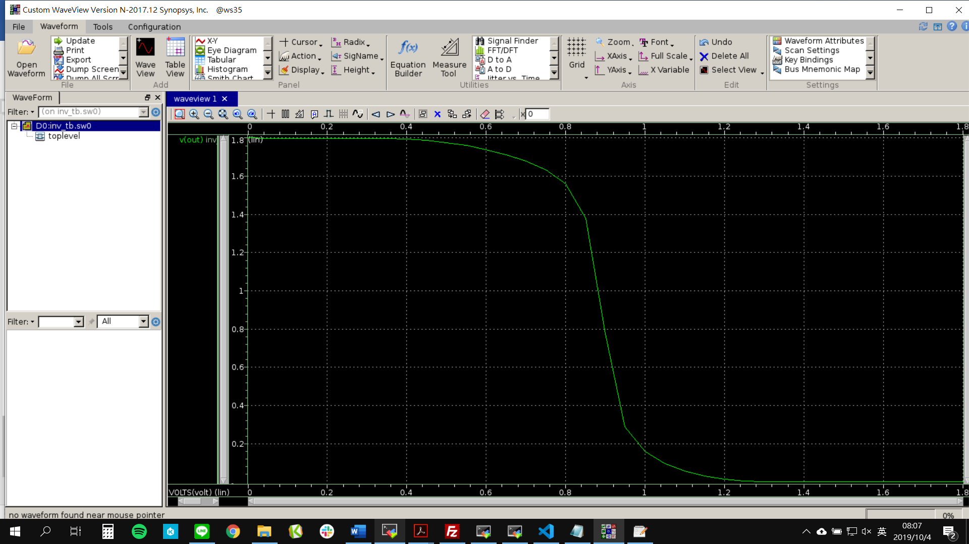

FF width 5x

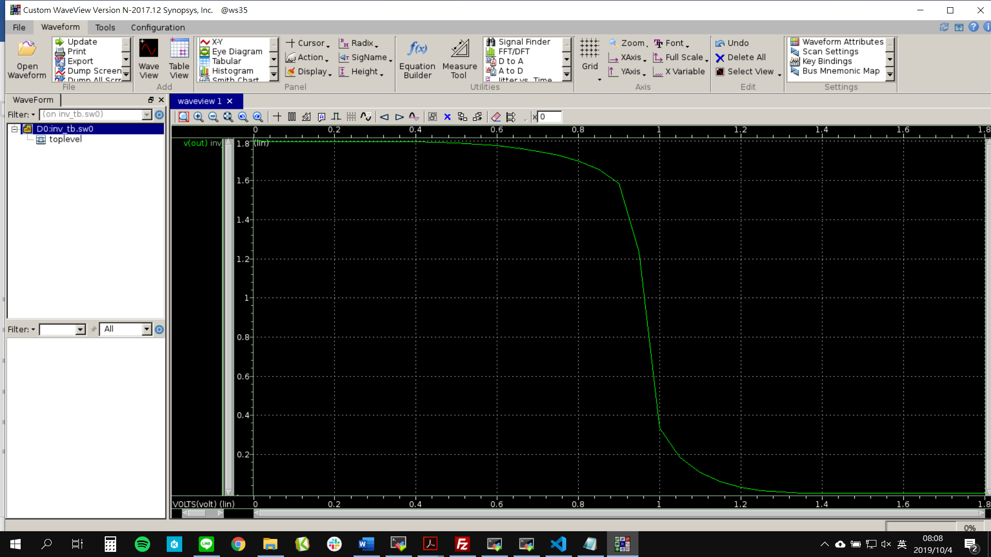

SS width 5x

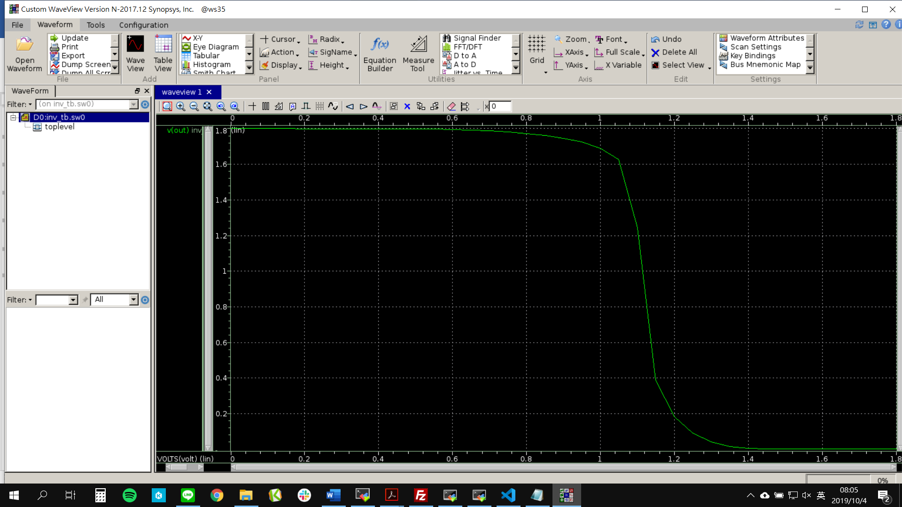

SF width 5x

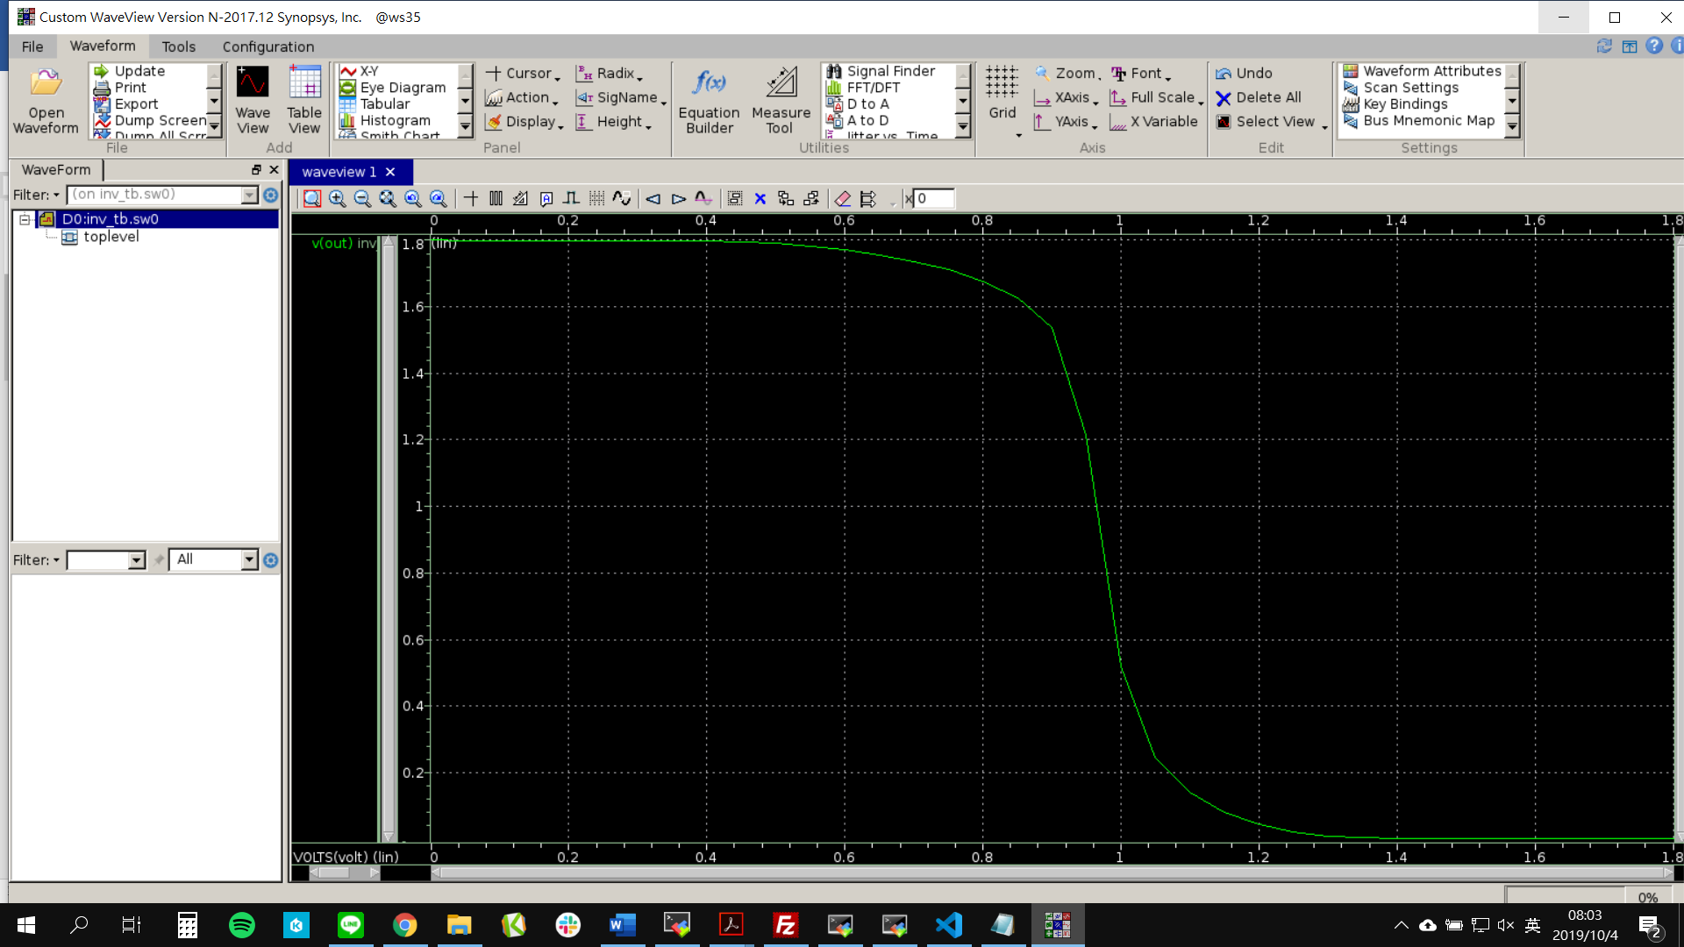

FS width 5x

|  |  |  |  |
| --- | --- | --- | --- |
| Process | Temperature | width 1X | width 5X |
| TT | 25℃ | 67.3 | 1.13 |
| FF | -40℃ | 49.9 | 786m |
| SS | 125℃ | 90.3 | 1.69 V |
| SF | 25℃ | 1.39 V | 1.75 V |
| FS | 25℃ | 114 | 1.54 V |

4.

|  |  |  |  |  |  |
| --- | --- | --- | --- | --- | --- |
| Process | Temperature | width 1X  Fall | width 1X  Rise | width 5X  Fall | width 5X  Rise |
| TT | 25℃ | 0.9 ns | 1.5 ns | 0.9ns | 1 ns |
| FF | -40℃ | 0.7 ns | 2s | 0.7 ns | 0.6 ns |
| SS | 125℃ | 1.8 ns | 5.2 ns | 2.4 ns | 1.2 ns |
| SF | 25℃ | 2 ns | 2 ns | 1 ns | 0.6 ns |
| FS | 25℃ | 1 ns | 2.2 ns | 1 ns | 0.6 ns |